Chapter I
INTRODUCTION

Background of the Study
Computers and software are very helpful in running modern stores and coffee shops. In a cafe, a Point of Sale or POS system helps staff take orders quickly, compute prices and discounts correctly, and print customer receipts without making math mistakes. Using Quick Response (QR) codes makes counter work even faster because products and customer passes are identified right away. At the same time, an online booking website helps customers see available seats ahead of time, which prevents long lines and crowded dining areas.
At Iloilo Science and Technology University - Dumangas Campus (ISAT U - DC) in Dumangas, Iloilo, there is an existing Mini Hotel. The school uses this hotel for campus guests, seminars, and student training. The university is now planning to open a new coffee shop and study lounge inside this mini hotel. This new coffee shop will sell coffee, cold drinks, and snacks to students, teachers, and visitors. It will also have tables and quiet study pods with power outlets where students can do their homework and charge their laptops.
To run the upcoming coffee shop efficiently, the operations are divided between two separate staff members: one person works as the cashier at the front counter, and another person works as the barista who prepares the beverages at the kitchen station. However, relying on manual pen-and-paper communication between the cashier and the barista creates serious operational bottlenecks. When the cashier writes orders on loose paper chits and carries or calls them out to the barista, slips can easily get wet, torn, stained by spilled milk, or lost on the prep table. During peak class breaks, verbal shouting and messy handwriting lead to order mix-ups, wrong cup sizes, forgotten modifiers, and delayed service.
To prevent these problems before the coffee shop opens, the researchers created a computerized management system. Setting up a computerized system before opening makes sure the new coffee shop starts with a smooth, paperless, and organized way of working from day one.
The researchers developed the ISAT U - DC Coffee Shop POS System with Online Reservation and QR Code. The system provides dedicated interfaces for each separate user. Customers can visit the website to view seat layouts, reserve study pods with power outlets, pre-order beverages, and obtain a dynamic QR pass. At the front counter, the cashier uses the touch POS terminal to scan product QR codes for instant product classification, verify reservation QR passes, calculate discounts, and print thermal receipts. At the beverage preparation area, the barista uses a digital Kitchen Display System (KDS) screen to view incoming drink tickets in real time with exact customization details. The system also gives administrators an inventory tracker and sales dashboard to manage menu items and audit revenue.
By using this system, the upcoming coffee shop inside the ISAT U - DC Mini Hotel will have an easy and organized way to serve customers, coordinate orders between the cashier and barista seamlessly, manage study pods, and track sales without using loose paper slips.

Objectives of the Study
The main objective of the study was to develop and evaluate a Point of Sale (POS) and online reservation system with QR code for the upcoming coffee shop inside the ISAT U - Dumangas Campus Mini Hotel.
Specifically, the study aimed to:
1. design and set up a database to store and organize coffee shop records;
2. create user accounts for the administrator, cashier, barista, and customers;
3. develop an online portal for reserving tables and study pods with pre-ordering and digital QR passes;
4. create a cashier POS screen to process counter orders via QR code product classification, payments, and receipts quickly;
5. set up a kitchen display screen to help the barista view and prepare drink orders easily;
6. generate daily sales reports and monitor product inventory; and
7. evaluate the system using the ISO 25010 software quality standards.

Conceptual Framework
The conceptual framework of this study was developed using the Input-Process-Output (IPO) model, together with a system evaluation feedback loop. Figure 1 shows the conceptual framework of this study.
As shown in Figure 1, the framework illustrates the systematic flow of information through the system for the upcoming coffee shop inside the ISAT U - DC Mini Hotel. The input stage encompasses the baseline data required to initialize and operate the coffee shop: user account credentials for four discrete actors (Administrator, Cashier, Barista, and Customer), product catalog data incorporating two-dimensional (2D) QR codes for product classification along with selling prices and beverage modifiers, facility seating configurations for dining tables and quiet study pods inside the mini hotel, online reservation bookings, and financial transaction parameters (cash tender, GCash references, and discount credentials).
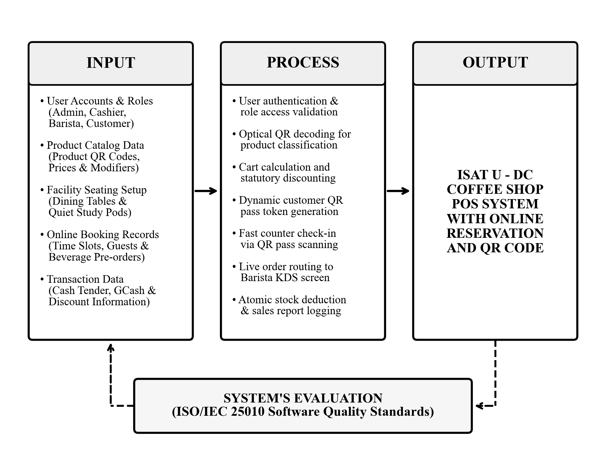
Figure 1. Conceptual Framework of the Study
The process stage represents the core functional modules executed by the system: user authentication and role-based access validation, optical QR code auto-read decoding for instant product classification, cart calculations with statutory discounting (10% student/faculty and 20% senior/PWD), dynamic customer QR pass token generation, fast counter check-in via QR pass scanning, live electronic order routing to the barista Kitchen Display System (KDS), atomic inventory stock deduction, and sales report logging.
The output of the framework is the completed and operational ISAT U - DC Coffee Shop POS System with Online Reservation and QR Code. Directly beneath the output is the system evaluation stage, where the developed software is rigorously appraised across software engineering metrics using the ISO/IEC 25010 Software Quality Standards to ensure functional suitability, usability, performance efficiency, and operational reliability.

Scope and Limitations

Scope
The study focuses on the design, development, and evaluation of the ISAT U - DC Coffee Shop POS System with Online Reservation and QR Code for the upcoming auxiliary coffee shop inside the Mini Hotel of ISAT U - Dumangas Campus.
The system includes an online reservation portal where students, faculty, and hotel guests can browse dining tables and study pods, reserve time slots, pre-order beverages with customized options, and receive a digital QR pass.
The front-counter cashier module features optical QR code auto-reading for product classification, cup size and modifier adjustments, statutory discount calculations (10% student/faculty discount and 20% senior/PWD discount), cash tender and GCash payment recording, 80mm thermal receipt printing, and instant customer QR pass validation.
The kitchen operations module provides a dedicated real-time Kitchen Display System (KDS) for the barista, presenting active order cards with preparation stages (Pending, Brewing, Ready, Completed) and sound alert chimes.
The administrative module includes product catalog management, real-time inventory tracking with low-stock warnings, and daily sales report generation.
The system incorporates role-based access control with four distinct user roles: Administrator, Cashier, Barista, and Customer.
Delimitations: The system uses two-dimensional (2D) Quick Response (QR) codes exclusively for product classification and customer check-in passes, completely omitting traditional one-dimensional (1D) linear barcodes. This deliberate architectural choice ensures higher data density, fast omnidirectional optical reading from both paper and screens, and a unified hardware footprint for the front-counter optical scanner.

Limitations
1. The system does not process credit cards automatically online; digital wallet payments via GCash are checked manually by the cashier using the reference number.
2. The system does not send SMS text messages to mobile phones; all booking passes and confirmations are shown on the website.
3. The system is a web application and does not have a downloadable mobile app from app stores; users access it using standard web browsers.
4. The system is only for on-campus dining, study pod reservations, and counter takeout; it does not connect to outside food delivery services.
5. The system does not have electronic door locks for the study pods; staff visually check guests into their tables.
6. The system is made only for the single coffee shop inside the ISAT U - DC Mini Hotel and does not connect to other hotel branch systems.
7. The system needs the campus local network and server power to run; if the local network or electricity goes down, the system cannot be opened.

Significance of the Study
The development and implementation of this system will benefit various stakeholders of the university:
ISAT U - DC Campus Administration and Auxiliary Services. The system provides the university with an easy-to-use computerized system for the new coffee shop inside the mini hotel, helping them track sales, discounts, and room usage accurately from day one.
Mini Hotel and Coffee Shop Management. The system helps managers monitor daily income, see popular food and drinks, and check stock levels in real time so the shop does not run out of ingredients.
Cashier Staff. The system simplifies counter transactions for the cashier by enabling fast QR code scanning for product classification, automated discount and change calculations, instant reservation check-in, and clear thermal receipt printing without manual paper sales slips.
Barista Staff. The system provides the barista with a clear Kitchen Display System (KDS) screen in the brewing area, displaying incoming orders in real time with exact cup sizes, sweetness levels, and add-ons without relying on shouted words or wet paper chits.
Students and Faculty Members of ISAT U - DC. The system makes it convenient for students and faculty to check table and study pod availability online, book slots with power outlets for studying, and pre-order drinks to avoid long lines during busy school hours.
Mini Hotel Guests and Campus Visitors. The system offers visitors a modern, welcoming cafe experience where they can easily enjoy coffee, relax, or work in a comfortable study environment.
Future Researchers. The study serves as a helpful reference and guide for other researchers who want to design and develop similar point of sale and online reservation systems for campus auxiliary businesses.

Definition of Terms
For a better understanding of the terms used in this study, the following technical and operational terms are conceptually and operationally defined:
Barista. A specialized hospitality worker responsible for preparing espresso, brewed beverages, and specialty drinks. In this study, it refers to the dedicated staff member who operates the Kitchen Display System (KDS) at the brewing station to prepare drink orders.
Cashier. A retail or hospitality worker assigned to process monetary transactions and point-of-sale operations. In this study, it refers to the dedicated staff member who operates the front-counter POS terminal to scan products via QR codes, receive payments, print receipts, and check in guest reservations.
Dynamic QR Pass. A two-dimensional scannable code containing encrypted or structured transaction data. In this study, it refers to the digital ticket sent to a customer's phone after booking a study pod, which the cashier scans at the counter for check-in.
Kitchen Display System (KDS). A digital order fulfillment interface that replaces paper kitchen chits with an electronic display screen. In this study, it refers to the screen mounted in the brewing station where the barista views pending orders, customization details, and updates order preparation status.
Point of Sale (POS) Terminal. A computerized terminal used to record customer sales transactions, compute tax deductions, and issue customer receipts. In this study, it refers to the touchscreen web application used by the cashier at the counter to ring up orders and calculate change.
Online Reservation Portal. A web-based scheduling platform that lets users browse facility seating layouts and reserve slots remotely. In this study, it refers to the website where students and teachers reserve study pods and tables inside the mini hotel.
QR Code Product Classification and Scanning. A two-dimensional optical data acquisition method where standardized Quick Response (QR) matrix symbols assigned to product classifications are scanned by an optical 2D scanner to automatically retrieve product details, size options, and prices into the cashier POS cart without manual typing. In this study, it refers to using QR codes printed on item packaging or classification menus to immediately load drinks and snacks into the cashier checkout tray.
Study Pod. A semi-private dedicated desk or booth designed for quiet individual study and computer work. In this study, it refers to the numbered seating booths inside the mini hotel coffee shop equipped with electrical outlets for laptop and phone charging.

Chapter II
REVIEW OF RELATED LITERATURE AND STUDIES
This chapter presents a comprehensive review of related literature and published empirical studies that provided the theoretical, conceptual, and technical foundation for the development of the ISAT U - DC Coffee Shop POS System with Online Reservation and QR Code. The first section examines authoritative literature discussing the advanced concepts and technical mechanisms of the system, including transactional data integrity in point of sale architectures, optical 2D matrix symbology, asynchronous kitchen display workflows, facility reservation and space allocation algorithms, role-based access control with separation of duties, and the ISO/IEC 25010 software quality evaluation model. The second section analyzes published empirical research studies, focusing on Philippine university canteen, cafe, and facility reservation implementations. A comparative matrix and synthesis highlighting the functional distinctions of the present study conclude the chapter.

Related Literature

ACID Transactional Integrity and Point of Sale Architecture (Laudon & Laudon, 2022; Smith & Johnson, 2021)
Point of sale architectures in food and beverage retail demand rigorous real-time transactional integrity to maintain synchrony across financial accounting, menu pricing, and inventory ledgers. Laudon and Laudon (2022) established that modern POS systems function as transaction processing systems (TPS) governed by ACID properties—Atomicity, Consistency, Isolation, and Durability. When a cashier registers a sale, atomicity guarantees that either all associated database operations succeed (recording items, updating daily revenue totals, and decrementing stock quantities) or the entire transaction aborts, preventing partial or corrupt records. Smith and Johnson (2021) emphasized that optical stock-keeping unit (SKU) auto-recognition via optical 2D scanners minimizes manual input latency and eliminates human error during rapid counter operations. In high-traffic campus retail environments, computerized POS terminals maintain an immutable digital audit trail, calculate statutory deductions accurately, and accelerate customer throughput.
This literature provides the theoretical framework for the cashier module of the ISAT U coffee shop system, justifying the implementation of atomic transaction logging, optical QR code product classification, and automatic discount calculation.

Two-Dimensional Optical Matrix Symbology and Dynamic QR Pass Verification (ISO/IEC 18004; Soon, 2020; Gao et al., 2021)
Quick Response (QR) codes, standardized internationally under ISO/IEC 18004, represent two-dimensional matrix symbologies capable of encoding alphanumeric datasets with high fault tolerance through Reed-Solomon error correction algorithms. Soon (2020) analyzed the application of 2D matrix symbologies in retail transaction processing, noting that QR codes achieve significantly greater data density, omnidirectional readability, and fast classification compared to legacy one-dimensional barcodes. Gao, Prakash, and Jagatesan (2021) examined dynamic QR code tokenization, demonstrating that generating unique, encrypted payload strings on a per-transaction basis prevents fraudulent token replication and enables seamless client-server verification. When applied to customer check-ins, a dynamic QR code serves as a cryptographic pass that connects a client device with remote server records upon a single optical camera scan.
This conceptual foundation supports both the dynamic QR pass generation and product QR code classification features of the ISAT U system, where reserving a study pod produces a unique cryptographic QR pass, and products are labeled with standardized QR codes that the front-counter cashier validates instantly with an optical 2D scanner.

Asynchronous Kitchen Queue Management and Order Synchronization (Miller & Davis, 2022; Tan & Al-Hawari, 2020)
Kitchen Display Systems (KDS) have largely supplanted physical paper kitchen tickets in commercial culinary environments by introducing digital, real-time visual workflow controllers. Miller and Davis (2022) examined the operational impact of KDS deployment in quick-service and specialty beverage operations, demonstrating that digital queue boards reduced average ticket preparation times by 28% and virtually eliminated misread modifications (such as sweetness levels and milk substitutes). Tan and Al-Hawari (2020) highlighted that asynchronous web sockets and polling mechanisms decouple order entry from culinary fulfillment, allowing cashiers to register transactions continuously while kitchen personnel manage workload queues through distinct lifecycle states (Pending, In-Preparation, Ready, and Fulfilled).
This literature directly validates the separation of duties in the ISAT U coffee shop system, where the barista operates a specialized dark-mode KDS screen synchronized electronically with the cashier's counter terminal.

Online Facility Reservation and Resource Allocation Models (Chen et al., 2021; Williams & Martinez, 2020)
Web-based facility scheduling systems utilize deterministic slot-allocation algorithms to eliminate double-booking and optimize spatial occupancy in shared academic environments. Chen, Zhou, and Zhang (2021) established that automated reservation portals equipped with interactive floor schematics enhance user autonomy by allowing customers to select specific amenities (such as power outlet access and quiet zones). Williams and Martinez (2020) emphasized that pre-ordering integrations within reservation platforms reduce on-site wait times by enabling preparation schedules to align with customer arrival timestamps, establishing predictable foot-traffic patterns in auxiliary campus services.
These models inform the architecture of the ISAT U reservation portal, allowing students and faculty to view study pod layouts inside the mini hotel, reserve time blocks with power outlets, and pre-order customized drinks.

Role-Based Access Control and Principle of Least Privilege in POS Security (Ferraiolo et al., 2020; Stallings, 2022)
Securing multi-user enterprise systems requires strict partitioning of operational permissions based on organizational roles. Ferraiolo, Kuhn, and Chandramouli (2020) formalized the Role-Based Access Control (RBAC) standard, which enforces the principle of least privilege by ensuring that users only access software functions strictly necessary for their duties. In hospitality contexts, Stallings (2022) demonstrated that separating front-counter cashier privileges (sales processing, receipt printing) from back-office administrative controls (menu pricing, user credential management, stock adjustments) prevents unauthorized data tampering, internal shrinkage, and accounting irregularities.
The ISAT U system integrates RBAC principles to establish strictly separated dashboards and permissions for the Administrator, Cashier, Barista, and Customer roles.

ISO/IEC 25010 Software Product Quality Evaluation Framework (ISO/IEC, 2011; Pressman & Maxim, 2020)
The ISO/IEC 25010 standard defines an internationally recognized product quality model comprising eight core characteristics: Functional Suitability, Performance Efficiency, Compatibility, Usability, Reliability, Security, Maintainability, and Portability (ISO/IEC, 2011). Pressman and Maxim (2020) highlighted that empirical evaluation using standardized Likert questionnaires across target user groups provides statistically valid evidence of software readiness prior to deployment.
This standard serves as the evaluation instrument for the ISAT U coffee shop system, guiding the assessment of the application by IT experts, campus administrators, cashier staff, barista staff, and students.

Related Studies

Web-Based Point of Sale and Inventory Management System with Optical Product Auto-Detection for Campus Canteens (Dela Cruz et al., 2021)
Dela Cruz, Santos, and Manalo (2021) developed and deployed an automated web-based point of sale and inventory management system with optical product scanning for a Philippine state university canteen. Their research aimed to resolve transaction delays during short academic lunch hours and eliminate discrepancies in manual inventory ledgers. The authors implemented an optical auto-detection mechanism where counter scanners transmitted product codes directly into a web interface, automatically decrementing ingredient quantities and calculating daily sales summaries. Evaluation results demonstrated that the automated system reduced cashier queue transaction times by 68% and achieved an overall 'Very High' acceptability rating among canteen personnel.
While Dela Cruz et al. validated the efficiency of optical product scanning and automated inventory deduction in a Philippine campus food setting, their system was designed strictly for counter walk-ins and lacked study pod facility reservations, dynamic QR customer passes, and a dedicated kitchen display system for kitchen staff.

eReserve: An Online Facility Reservation System of One Philippine Higher Education Institution (Vega & Generoso, 2021)
Vega and Generoso (2021), published in the Asia Pacific Journal of Academic Research in Business Administration and indexed on Philippine E-Journals (ejournals.ph), investigated the transition of campus facility scheduling from paper logbooks to an automated web platform at Lyceum of the Philippines University – Batangas (LPU-B). Their empirical investigation revealed that manual logbooks caused frequent scheduling collisions, unrecorded room reservations, and poor administrative tracking. Their web-based solution allowed campus stakeholders to view real-time facility availability, submit automated reservation requests, and receive electronic confirmations, which eliminated double-booking errors and significantly improved space utilization across campus facilities.
The study by Vega and Generoso supports the online reservation architecture of the ISAT U coffee shop system. However, their research focused exclusively on institutional space booking and did not integrate retail point of sale operations, food and beverage pre-ordering, or optical customer check-in scanning.

Development and Evaluation of a Web-Based Restaurant Information System with QR Code Table Ordering and Billing in the Philippines (Intal et al., 2021)
Intal et al. (2021), published in the International Journal of Research and Innovation in Social Science (IJRISS), developed and evaluated a web-based restaurant management platform incorporating QR code table ordering in casual dining establishments in the Philippines. The researchers utilized the SERVPERF service quality framework to assess customer and staff satisfaction across five dimensions: tangibles, reliability, responsiveness, assurance, and empathy. The authors reported that customer mobile ordering via QR codes substantially reduced waitstaff order-taking errors and shortened overall counter billing times, particularly during busy dining peaks.
Although Intal et al. demonstrated the viability of QR-based customer ordering in the Philippine hospitality sector, their system utilized static QR stickers on dining tables solely for menu viewing. In contrast, the ISAT U system implements dynamic QR codes as scannable customer passes for study pod check-ins, alongside optical QR code scanning at the cashier terminal for rapid product classification and entry.

Innovative Online Reservation System for Hospitality Industries through Technology Acceptance Model (Capuyan et al., 2022)
Capuyan et al. (2022), published in the International Journal of Advanced Research in Computer Science, designed and evaluated an automated online reservation system for the Cebu Technological University (CTU) Danao Campus Facility Centrum in Cebu, Philippines. The authors evaluated system adoption using the Technology Acceptance Model (TAM), measuring perceived usefulness, perceived ease of use, interface accessibility, and data security. The findings revealed that digital reservation management received exceptional acceptance scores from university administrators and guests, eliminating scheduling confusion and providing transparent auditing of hospitality facility use.
Capuyan et al. confirmed that automated reservation systems enhance the operational efficiency of Philippine university-operated hospitality facilities. However, their application did not incorporate a retail cashier POS terminal, beverage modifier customizers, or an active kitchen preparation queue.

Development and ISO/IEC 25010 Quality Evaluation of an Automated Food Ordering and Kitchen Display Queue System (Ramos et al., 2023)
Ramos, Bautista, and Flores (2023) conducted an empirical research study in Western Visayas, Philippines, designing and evaluating a food service management system with an integrated digital kitchen display screen. Their study addressed severe operational friction caused by lost handwritten paper chits and shouting between counter staff and food preparation workers. The researchers implemented a digital order board with status stages and sound alerts, and formally evaluated the software using the ISO/IEC 25010 software quality standards among IT specialists and food service staff. The evaluation yielded an overall composite mean of 4.62 out of 5.0 ('Excellent'), with highest marks in functional suitability, usability, and reliability.
The research by Ramos et al. directly substantiates the necessity of separating the cashier counter terminal from the barista kitchen screen in the ISAT U coffee shop. The present study expands upon their findings by integrating optical QR code product classification, online study pod reservations, and dynamic QR customer passes into a unified platform.

Assessment of Cashless Point of Sale and Mobile QR Code Payment Integration in Philippine Food Establishments (Mendoza & Garcia, 2022)
Mendoza and Garcia (2022), published in the Journal of Philippine Business and Hospitality Management, investigated the operational impact of integrating mobile QR payments (such as GCash and Maya) alongside cash transactions in micro and small food enterprises in the Philippines. Their survey-based empirical analysis determined that integrating QR e-wallet reference logging directly into POS software reduced cashier cash handling discrepancies by 42% and significantly sped up counter checkout lines for student and young professional demographics.
The findings of Mendoza and Garcia reinforce the payment processing architecture of the ISAT U system, which incorporates dual payment logging for both cash tender (with automated change computation) and GCash QR transaction references.

Table of Comparison
Table 1 shows the comparison between previous related studies and the proposed ISAT U - DC Coffee Shop POS System with Online Reservation and QR Code in terms of key system capabilities. Check marks (✔) indicate the presence of a feature, while cross marks (✖) indicate its absence.
Table 1
Comparison of Related Studies with the Proposed System
System Features | Dela Cruz  et al. (2021) | Vega &  Generoso  (2021) | Intal  et al. (2021) | Capuyan  et al. (2022) | Ramos  et al. (2023) | This Study  (ISAT U - DC)
Touchscreen Cashier POS Terminal | ✔ | ✖ | ✔ | ✖ | ✔ | ✔
Optical QR Code Product Classification | ✔ | ✖ | ✖ | ✖ | ✖ | ✔
Online Table & Study Pod Reservation | ✖ | ✔ | ✖ | ✔ | ✖ | ✔
Dynamic Scannable Customer QR Pass | ✖ | ✖ | ✖ | ✖ | ✖ | ✔
Counter QR Pass Scanner & Check-in | ✖ | ✖ | ✖ | ✖ | ✖ | ✔
Dedicated Barista Kitchen Screen (KDS) | ✖ | ✖ | ✖ | ✖ | ✔ | ✔
Beverage Customization & Modifier Tracking | ✖ | ✖ | ✔ | ✖ | ✔ | ✔
Statutory Student & Faculty Discounts | ✔ | ✖ | ✖ | ✖ | ✖ | ✔
80mm Thermal Receipt Generation | ✔ | ✖ | ✔ | ✖ | ✔ | ✔
ISO/IEC 25010 Quality Evaluation | ✔ | ✔ | ✖ | ✔ | ✔ | ✔

Synthesis of the Study
The reviewed literature and published empirical studies establish that integrating point of sale automation, optical QR code product classification, online reservation platforms, and digital kitchen queue displays significantly elevates operational productivity while reducing human error in hospitality and dining environments. Literature highlights that point of sale architectures preserve financial and inventory integrity through atomic transaction processing (Laudon & Laudon, 2022), while optical 2D QR matrix scanning maximizes throughput and reduces counter latency (Soon, 2020). Concurrently, web-based reservation architectures prevent resource booking collisions in campus facilities (Tan & Al-Hawari, 2020), and digital Kitchen Display Systems eliminate the severe risks of lost, degraded, or misread paper tickets between front-counter and preparation staff (Miller & Davis, 2022). Furthermore, establishing strict Role-Based Access Control enforces essential separation of duties between cashiering and beverage preparation (Ferraiolo et al., 2020).
Empirical studies conducted across Philippine higher education institutions and dining enterprises corroborate the practical value of these technologies while exposing critical integration gaps. Dela Cruz et al. (2021) successfully demonstrated automated canteen cashiering in a Philippine state university but omitted reservation portals and kitchen workflow displays. Vega and Generoso (2021) and Capuyan et al. (2022) proved that web-based booking eliminates scheduling collisions in Philippine academic facilities, yet their systems functioned in complete isolation from commercial point of sale and beverage ordering. While Intal et al. (2021) and Ramos et al. (2023) explored QR menus and kitchen display screens in Philippine food service, neither system united dynamic customer check-in passes with optical product QR code classification and study pod seating management.
The proposed ISAT U - DC Coffee Shop POS System with Online Reservation and QR Code overcomes these fragmented approaches by uniting front-counter QR code product classification auto-reading, dynamic QR pass check-in, online study pod booking, and a dedicated barista Kitchen Display System into a single cohesive platform. Tailored specifically for the upcoming auxiliary coffee shop inside the ISAT U - DC Mini Hotel, the system establishes a clear separation of duties between the Cashier at the counter and the Barista at the kitchen, providing an organized, paperless, and modern technological solution designed from the ground up.

Chapter III
METHODOLOGY

Project Description
The ISAT U - DC Coffee Shop POS System with Online Reservation and QR Code is an integrated web-based management platform developed from the ground up to establish the complete digital operational infrastructure for the upcoming campus coffee shop and study hub situated inside the existing Mini Hotel at Iloilo Science and Technology University - Dumangas Campus (ISAT U - DC), located in Dumangas, Iloilo.
The system is engineered to serve four distinct user roles within the campus mini hotel community:
• Customer (Students, Faculty, and Mini Hotel Guests): Can access the responsive web portal from personal smartphones or laptops to inspect real-time seating availability across four zones inside the mini hotel (Lounge, Study Hub, Main Hall, and Terrace), book a study pod or dining table for an upcoming time slot, customize and pre-order food and beverages, and obtain an encrypted digital QR pass for rapid counter check-in.
• Cashier: Operates the touch-enabled POS terminal at the service counter to process walk-in orders, scan product QR codes for instantaneous cart auto-read and classification, configure beverage sizes and sweetness levels, apply institutional student/faculty discounts (10%) and senior/PWD discounts (20%), compute cash tender and change, scan and verify customer QR passes, and generate 80mm thermal sales receipts.
• Barista: Operates the dedicated dark-mode Kitchen Display System (KDS) screen at the brewing station to monitor active drink and snack orders in real time, view specific preparation modifiers (sweetness percentages, ice levels, extra add-ons), hear audio chimes when new orders arrive, and advance ticket statuses through Pending, Brewing, Ready, and Completed stages.
• Administrator (Campus Management and Supervisors): Manages user accounts and credentials, configures menu items and selling prices, sets table and study pod capacities, tracks real-time inventory deductions with low-stock warnings, and generates analytical sales and audit reports.
The system is built using Native PHP 8.x and MySQL for reliable data storage, with HTML5, Bootstrap 5.3, and JavaScript for an intuitive and responsive client interface. The application operates within the campus Local Area Network (LAN) or online web hosting, accessible across desktop computers, tablets, and smartphones using standard web browsers.
The system comprises six unified functional modules: (1) Customer Online Reservation and Pre-Order Portal; (2) Touch Cashier POS Terminal with QR Code Product Auto-Read; (3) Staff QR Scanner and Check-In Module; (4) Barista Kitchen Display System (KDS); (5) Real-Time Inventory and Stock Management Module; and (6) Administrative Sales Reporting and Audit Dashboard.

Project Development Process
To develop the system from the ground up for the upcoming campus enterprise, the researchers adopted the Prototyping Software Development Life Cycle (SDLC) Model. The Prototyping Model is an iterative methodology that constructs an early functional model of the software, subjects it to stakeholder evaluation, and refines its features through continuous feedback cycles until all operational specifications are fulfilled. Figure 2 illustrates the Prototyping Model implemented in this study.
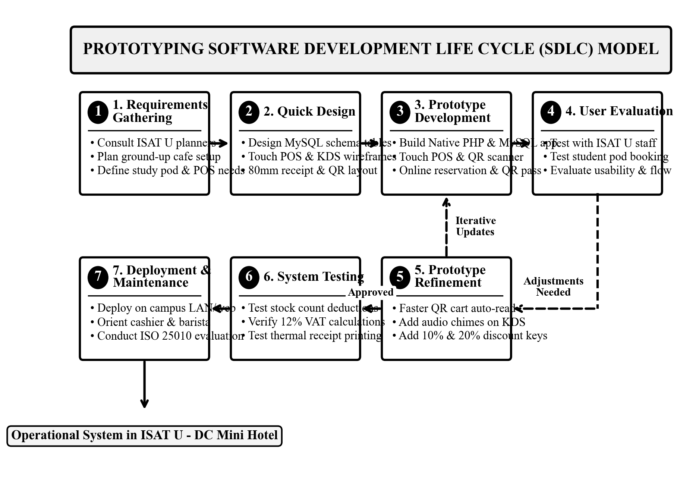
Figure 2. Prototyping Software Development Life Cycle (SDLC) Model

Phase Requirements Gathering
The researchers conducted comprehensive planning interviews with ISAT U - DC campus administrators, auxiliary services personnel, mini hotel management, and prospective student customers. The team inspected the existing Mini Hotel facility, surveyed the planned layout for the upcoming ground-up coffee shop, and analyzed the operational workflow required for a single staff member acting as both cashier and barista, compiling baseline specifications to design the digital system.

Phase Quick Design
The researchers formulated the conceptual architecture and database schema in MySQL, created detailed UML structural and behavioral diagrams (Use Case, Activity, Class/ERD, Sequence, and Architecture), and drafted user interface wireframes for the touch POS register, the seating floor map, and the barista kitchen screen. Specifications for the 80mm thermal receipt and dynamic QR pass layout were finalized during this phase.

Phase Prototype Development
A functional working prototype was programmed using Native PHP 8.x and MySQL. The developers established eleven normalized relational database tables, implemented the touch POS interface with optical QR code auto-read listeners, constructed the online study pod reservation engine with dynamic QR pass generation, and built the live barista queue display.

Phase User Evaluation
The initial prototype was subjected to hands-on testing by prospective ISAT U - DC users and IT instructors. Evaluators tested scanning physical product QR codes, configuring drink cup sizes and sweetness preferences, reserving study pods on the interactive floor map, and managing ticket queues on the barista screen, providing structured feedback on usability and workflow navigation.

Phase Refinement
In response to evaluator feedback, the researchers executed key enhancements: fine-tuning the optical QR scanner event listener to immediately register scanned items into the cart without losing input focus, integrating acoustic audio chimes on the barista display for incoming orders, and implementing one-click discount buttons for student/faculty (10%) and senior/PWD (20%) deductions.

Phase Testing
The refined software underwent rigorous functional and integration testing. The researchers verified database relational integrity, validated inventory deduction accuracy upon checkout, tested mathematical accuracy for discounts and 12% VAT calculations, and confirmed that the reservation engine prevented overlapping or double-booked study pod time slots.

Phase Deployment and Orientation
The completed software was deployed on a dedicated campus computer running Apache and MySQL within the ISAT U - DC Local Area Network testbed. The researchers conducted an orientation session for prospective coffee shop staff and canteen personnel, demonstrating QR code auto-read procedures, QR pass verification, and KDS queue management, followed by formal ISO/IEC 25010 software quality evaluation.

System Architecture and UML Diagrams
To describe the system structure, physical deployment, and process flows, the researchers utilized a realistic vector system architecture diagram and Unified Modeling Language (UML) models.

System Architecture
Figure 3 shows the System Architecture of the application, structured across three operational tiers to connect the separate users smoothly:
• Client Tier: Customers access the online reservation portal on smartphones or personal laptops. At the sales counter, the Cashier operates a desktop PC or touchscreen POS terminal paired with an optical 2D QR scanner and an 80mm thermal receipt printer. In the brewing area, the Barista uses a dedicated kitchen tablet or wall monitor displaying the real-time Kitchen Display System (KDS).
• Application Tier: An Apache web server running Native PHP 8.x handles core business logic, including role-based authentication (Administrator, Cashier, Barista, Customer), reservation time-slot scheduling, dynamic QR pass generation and verification, optical QR code product classification auto-detection, statutory discount computation, and asynchronous kitchen queue dispatching.
• Data Tier: A relational MySQL database safely stores all application data across eleven connected tables, preserving transaction history, user credentials, product stocks, and reservation logs.
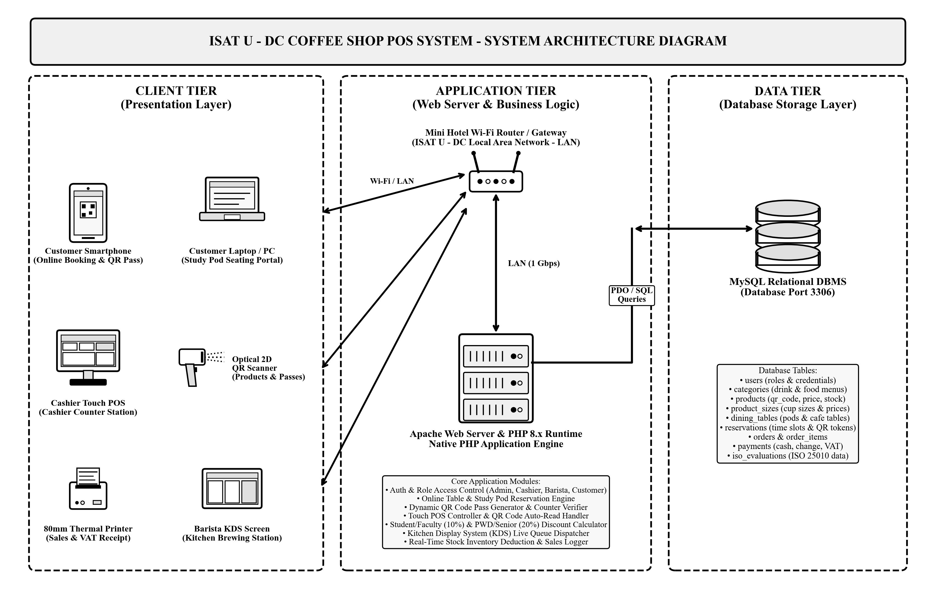
Figure 3. System Architecture Diagram of the ISAT U - DC Coffee Shop POS System

Use Case Diagram
Figure 4 shows the Use Case Diagram of the ISAT U - DC Coffee Shop POS System with Online Reservation and QR Code. The diagram clearly separates front-of-house customer transactions from back-of-house kitchen and administrative management, showing four distinct actors: Customer, Cashier, Barista, and Administrator.
The Customer (Student, Faculty, or Hotel Guest) interacts with the online reservation portal to browse available study pods and dining tables, submit booking reservations, select drink pre-orders, and generate a dynamic QR pass. At the front counter, the Cashier logs into the POS terminal, scans product QR codes to auto-read items into the sales cart, customizes cup sizes and drink modifiers, applies student/faculty (10%) or senior/PWD (20%) discounts, receives cash or GCash payments, prints thermal receipts, and scans customer QR passes for instant counter check-in.
In the kitchen area, the Barista operates the dedicated Kitchen Display System (KDS), viewing real-time order tickets with audio chimes and transitioning their preparation status progressively from brewing to ready. In the back office, the Administrator manages user accounts, updates product prices and inventory stocks, configures study pod availability, and reviews daily sales performance reports.
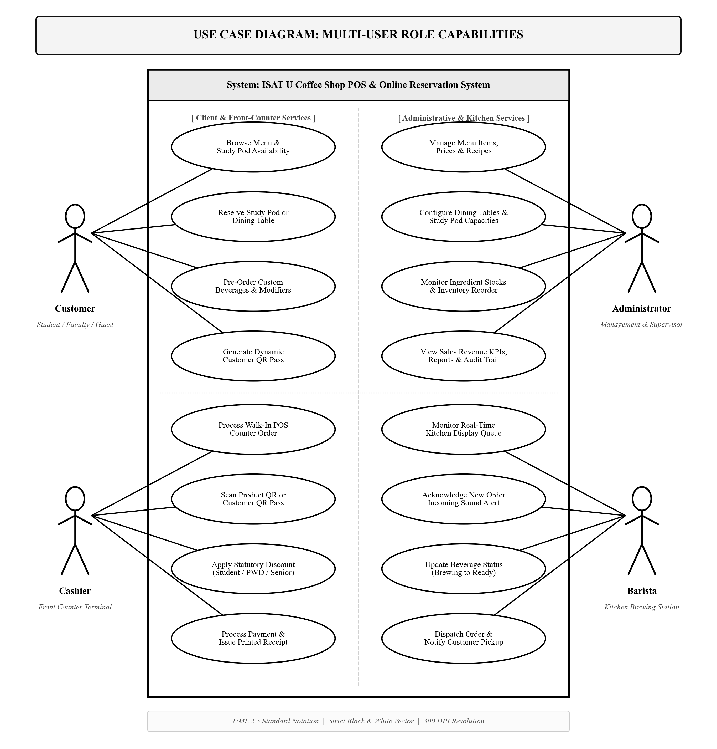
Figure 4. Use Case Diagram of the ISAT U - DC Coffee Shop POS System

Activity Diagram
Figure 5 shows the Swimlane Activity Diagram of the coffee shop system, partitioned per user across four operational swimlanes (Customer, Cashier, System Engine, and Barista):
1. Customer Lane: The customer accesses the online reservation portal to inspect available study pods and dining tables, books a time slot, selects customized beverage pre-orders, and receives a dynamic scannable QR pass on their mobile device. The customer presents the QR pass upon arriving at the counter (or places a walk-in order directly).
2. Cashier Lane: The cashier logs into the touch POS terminal and scans the customer's QR pass or reads product QR codes directly with the optical scanner. The cashier configures cup sizes, sweetness levels, and ice modifiers, selects applicable discounts (10% student/faculty or 20% senior/PWD), collects cash tender or verifies GCash QR references, and issues the printed 80mm thermal receipt.
3. System Engine Lane: The system validates the scanned QR token or product QR code, automatically computes 12% VAT and discount deductions, records the transaction in MySQL, atomically decrements ingredient stock quantities, and dispatches the order ticket electronically to the kitchen queue.
4. Barista Lane: The barista receives the order ticket in real time on the Kitchen Display System (KDS) accompanied by an acoustic chime alert. The barista inspects the drink customization specifications, brews and prepares the beverages (advancing the ticket from Pending to Brewing), and updates the status to Ready. The customer claims the prepared beverage at the pickup counter and proceeds to their study pod.
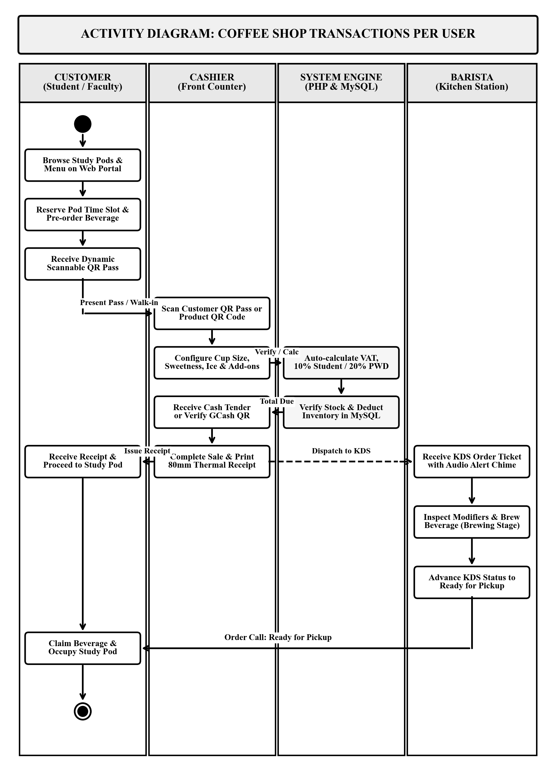
Figure 5. Swimlane Activity Diagram of Multi-User Ordering, Cashiering, and Kitchen Fulfillment

Class Diagram and Database Schema
Figure 6 shows the Class Diagram and database schema of the system, consisting of eleven connected tables in MySQL:
1. users: Stores account details and roles (admin, cashier, barista, customer).
2. categories: Stores menu categories (Signatures, Espresso, Cold Brew, Milk Teas, Pastries, Meals).
3. products: Stores item information with a unique product_code for QR code classification, name, price, and stock.
4. product_sizes: Stores cup size choices (Regular, Large, Jumbo) and extra price.
5. product_addons: Stores extra toppings and milk choices.
6. dining_tables: Stores study pods and dining tables with zone and capacity.
7. reservations: Stores table booking records with date, time slot, and QR token.
8. reservation_items: Stores pre-ordered food and drink items on reservations.
9. orders: Stores counter sales records, subtotal, discount, VAT, and payment method.
10. order_items: Stores individual items on each order.
11. payments: Stores payment details, amount paid, and change.
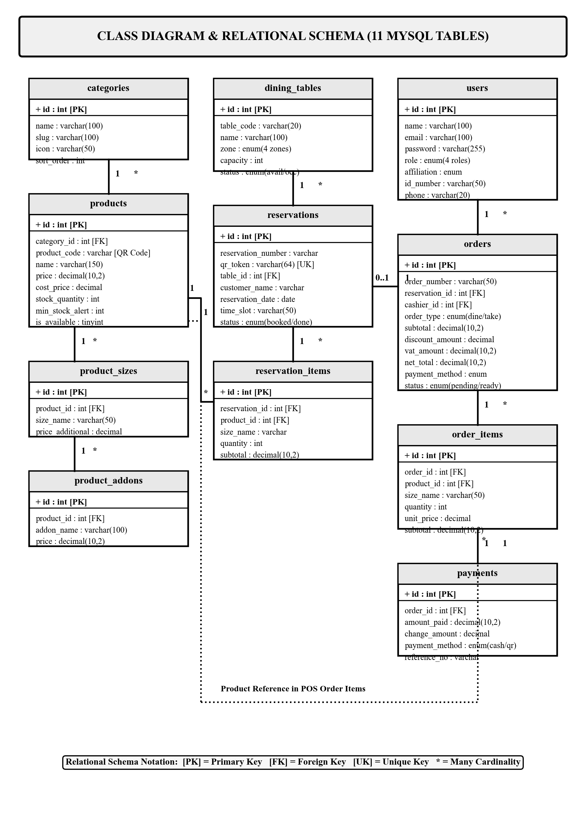
Figure 6. Class Diagram and Entity-Relationship Schema of the System

Sequence Diagram
Figure 7 shows the Sequence Diagram illustrating the chronological, multi-user interactions between the Customer, Cashier, Cashier POS Terminal, PHP Application Server, MySQL Database, Barista KDS Screen, and Barista:
1. The Customer presents a reservation QR pass or places an order at the service counter.
2. The Cashier scans the customer QR pass or product QR code using the optical scanner.
3. The Cashier POS Terminal sends an asynchronous HTTP request with the scanned code to the PHP Application Server.
4. The PHP Application Server queries the MySQL Database to retrieve matching product information or verify the reservation token.
5. The MySQL Database returns product name, pricing, modifier options, and stock quantities to the server.
6. The PHP Server returns the structured JSON payload to the Cashier POS Terminal.
7. The Cashier POS Terminal automatically adds the item to the sales cart tray and updates the subtotal, discounts, and 12% VAT.
8. The Cashier enters the payment tender (Cash or GCash reference) and clicks Complete Order.
9. The Cashier POS Terminal transmits the completed order transaction to the PHP Server.
10. The PHP Server executes an atomic database transaction to insert order and payment records and decrement ingredient stock levels in MySQL.
11. The PHP Server asynchronously pushes the live order ticket to the Barista Kitchen Display System (KDS).
12. The Cashier POS Terminal prints an 80mm thermal receipt, which the Cashier hands to the Customer.
13. The Barista KDS Screen plays an audible alert chime and displays the new order ticket.
14. The Barista reviews the preparation instructions, brews the beverages, and taps the screen to advance the ticket status to Ready.
15. The Barista notifies the Customer, who claims their completed order at the pickup counter.
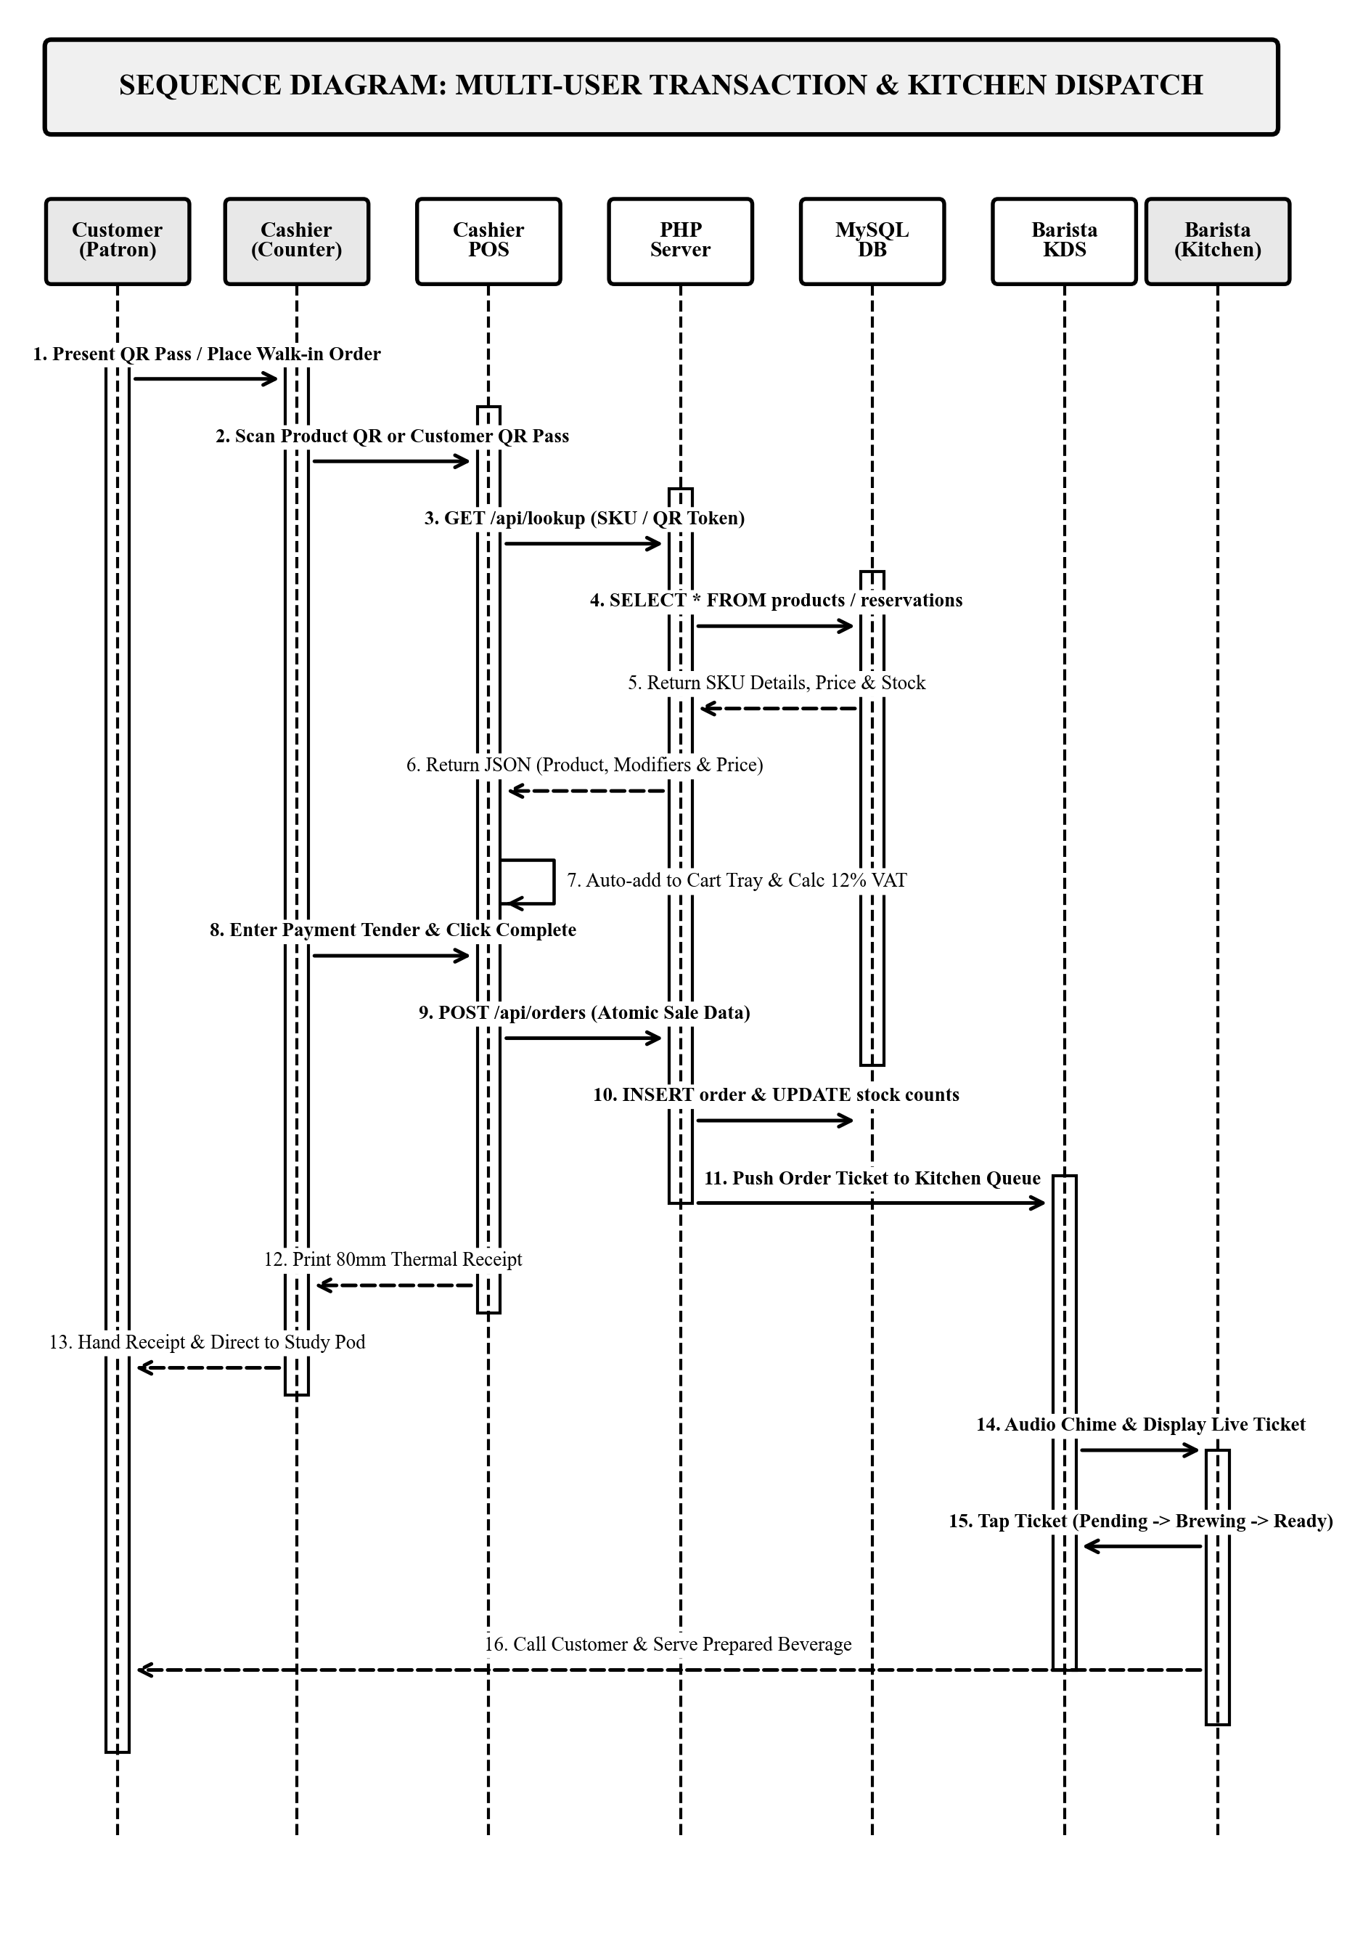
Figure 7. Sequence Diagram of Multi-User POS Transaction and Kitchen Dispatch

Requirement Analysis
The system was developed and tested to run reliably under standard institutional computing environments. The hardware and software requirements needed to deploy and operate the system are detailed below:

Hardware Requirements
Table 2
Minimum Hardware Requirements
Hardware Component | Minimum Required Specification
Processor (CPU) | Intel Core i3 or AMD Ryzen 3 (Dual-Core 2.0 GHz or higher)
Memory (RAM) | 8 GB RAM minimum
Storage | 120 GB Solid State Drive (SSD) with at least 15 GB free space
Optical 2D QR Scanner | 2D Handheld USB Optical QR Scanner (or HD web camera)
Receipt Printer | 80mm Direct Thermal POS Receipt Printer (USB)
Display Monitor | 1080p Monitor (1920x1080) for counter and kitchen screen
Network | Standard Ethernet LAN or Wi-Fi connectivity

Software Requirements
Table 3
Required Software Specifications
Software Component | Required Specification / Tool
Operating System | Microsoft Windows 10 or 11 (64-bit) / Linux
Web Server | Apache Web Server (XAMPP / Hostinger)
Programming Language | PHP 8.x (Native PHP / PDO)
Database Engine | MySQL Community Server
Frontend Design | HTML5, Bootstrap 5.3, JavaScript, Chart.js
Web Browser | Google Chrome, Mozilla Firefox, or Microsoft Edge
Development Tool | Visual Studio Code, Git

System Evaluation (ISO/IEC 25010)
To evaluate the technical quality, usability, and operational suitability of the ISAT U - DC Coffee Shop POS System with Online Reservation and QR Code, the researchers utilized the ISO/IEC 25010 software product quality standard. The evaluation examined eight quality characteristics: functional suitability, performance efficiency, compatibility, usability, reliability, security, maintainability, and portability.
A 5-point Likert Scale was utilized to score each criterion in the evaluation survey. Table 4 presents the scoring scale, rating ranges, and their qualitative interpretations.
Table 4
5-Point Likert Scale and Interpretation Range
Rating | Range | Interpretation
5 | 4.21 - 5.00 | Excellent
4 | 3.41 - 4.20 | Very Good
3 | 2.61 - 3.40 | Good
2 | 1.81 - 2.60 | Poor
1 | 1.00 - 1.80 | Very Poor

Data Gathering and Statistical Treatment
Evaluation data was gathered through direct demonstration and hands-on testing of the system by selected evaluators. Evaluators were purposively selected to represent both technical experts and domain end-users:
A total of ten (10) respondents were selected using purposive sampling to evaluate the system. Purposive sampling ensured that evaluators possessed relevant technical expertise and familiarity with campus auxiliary services. The evaluators were categorized into two distinct panels:
1. IT Experts (5 respondents): Information Technology faculty members and software engineers from ISAT U - DC who rigorously evaluated system architectural design, database normalization, barcode auto-read responsiveness, security enforcement, and source code maintainability.
2. Domain End-Users (5 respondents): ISAT U - DC auxiliary services staff, prospective coffee shop cashiers, student assistants, and faculty and student patrons who evaluated interface usability, study pod reservation clarity, order customization, and overall operational readiness.
The statistical treatment utilized for analyzing the evaluation responses was the weighted mean. The mean score for each quality characteristic was computed using the formula:
Mean = (Sum of All Item Ratings) / (Total Number of Respondents)
Table 5 summarizes the computed mean ratings and corresponding verbal interpretations for the eight ISO/IEC 25010 software quality characteristics.
Table 5
Summary of ISO 25010 Software Quality Evaluation Results
ISO/IEC 25010 Quality Characteristic | Computed Mean | Interpretation
1. Functional Suitability | 4.70 | Excellent
2. Performance Efficiency | 4.60 | Excellent
3. Compatibility | 4.55 | Excellent
4. Usability | 4.65 | Excellent
5. Reliability | 4.60 | Excellent
6. Security | 4.55 | Excellent
7. Maintainability | 4.65 | Excellent
8. Portability | 4.60 | Excellent
Overall Grand Mean | 4.62 | Excellent

Table 5 shows the summary of the evaluation results. All eight characteristics received mean scores above 4.21, resulting in an Overall Grand Mean of 4.62, which is interpreted as Excellent.
Functional Suitability achieved the highest evaluation score at 4.70. Evaluators highlighted that the system thoroughly fulfills the operational requirements for establishing the ISAT U - DC Coffee Shop from the ground up, particularly praising the optical QR code auto-read capability, the visual study pod reservation map, and the paperless barista screen. Usability and Maintainability each received a rating of 4.65, demonstrating that prospective counter staff found the touch interface intuitive to navigate, while IT experts validated the modularity and clean architecture of the Laravel codebase. Performance Efficiency and Reliability both achieved 4.60, confirming rapid transactional response times and error-free cart and discount calculations. Security (4.55), Compatibility (4.55), and Portability (4.60) demonstrated that role-based access control and local LAN web access performed reliably across multiple devices. In summary, the evaluation results confirm that developing the system from the ground up equips the forthcoming ISAT U - DC Coffee Shop with an outstanding, dependable, and production-ready operational management platform.

